Biography of Terry A. Davis – The Mad Programmer behind TempleOS

# Introduction

Terrence Andrew Davis (15 December 1969 – 11 August 2018) was an American programmer who alone created TempleOS, a biblical-themed operating system, which he claimed to be God’s Third Temple.

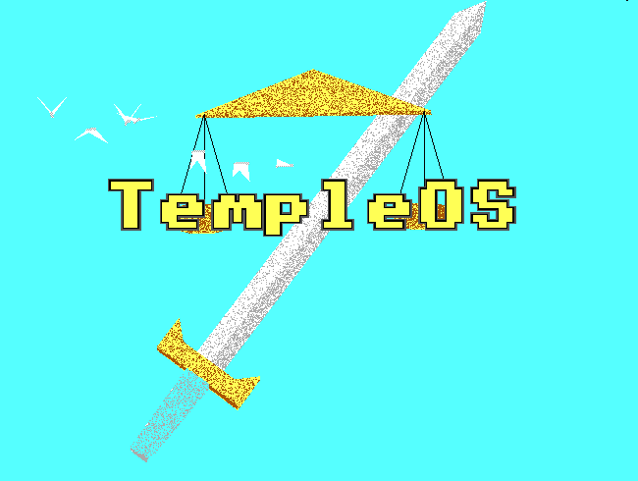

Logo of TempleOS from TempleOS.org

# Early Life and Career

Davis was born in West Allis, Wisconsin. As a teenager, he learned assembly language on a Commodore 64 home computer. Davis received his master’s degree in electrical engineering from Arizona State University in 1994 and worked for several years as a VAX machine programmer for Ticketmaster.

# Mental Illness

Davis was raised Catholic but was an atheist during his early adult life until he experienced what he called a “revelation from God”. Since 1996, Davis was admitted to a psychiatric ward several times due to his reoccurring manic episodes. He began developing delusions of space aliens and government agents he thought were following him.

Fearful of the figures in his delusions, Davis drove hundreds of miles out of town with no destination. Convinced that his car radio was communicating with him, Davis dismantled his vehicle in search for tracking devices which he believed had been secretly installed. He then threw away his keys to the desert and walked aimlessly along the highway until he was picked up by a police officer. While on the patrol vehicle, Davis managed to escape but shattered his collarbone. He was then taken to a hospital.

After hearing about artifacts found in his X-ray scans, Davis interpreted them as “alien artifacts” and ran away from the hospital out of distress. He attempted to carjack a nearby truck after escaping but was then arrested.



Picture of Terry A. Davis from Wikimedia Commons

# TempleOS

TempleOS (formerly J Operating System, LoseThos, and SparrowOS) is a Christianity-themed lightweight operating system designed by Terry A. Davis to be the Third Temple prophesied in the Bible. He developed it alone for a decade after experiencing a series of manic episodes which he later claimed to a revelation from God.

Davis conceived the idea of creating an operating system in the early 2000s. Over the course of a decade, Davis alone designed original programming language, editor, compiler, and kernel for his operating system, ultimately writing more than 100,000 lines of code.

In 2005, Davis expressed that his goal for the J Operating System was "to recreate the dynamic environment that used to exist when the Commodore 64 was around and everyone was creating odd-ball software". He envisioned the system as a Commodore 64 with a "thousand times" more powerful processing speed. After three years, he wrote that the primary purpose of LoseThos was "for making video games. It has no networking or Internet support. As far as I'm concerned, that would be reinventing the wheel".

Davis later claimed that he was in direct communication with God, and that God told him to create, according to the TempleOS charter, "God's official temple. Just like Solomon's temple, this is a community focal point where offerings are made and God's oracle is consulted."

TempleOS is an open source 64-bit PC operating system with an interface similar to Commodore 64 and other DOS-based interfaces. The system runs at 640x480 VGA with 16 colors, which, according to Davis, "is a covenant like circumcision," making it easier for children to draw illustrations for God. Like many other features of the system, Davis claimed that they were explicit instructions from God.

TempleOS was written in HolyC, a programming language Davis developed that is between C and C++, formerly called C

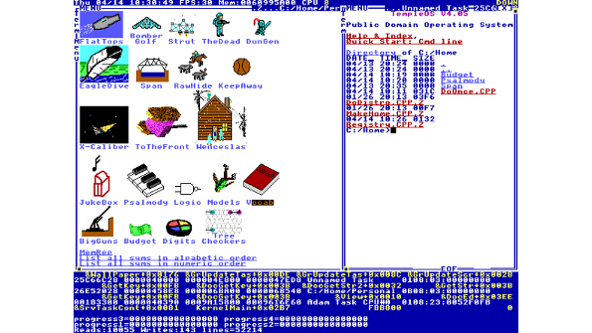

User Interface of TempleOS from Channel Futures

# Death

# Legacy

# References

<https://web.archive.org/web/20111008223814/http://www.losethos.com/>

<https://en.wikipedia.org/wiki/Terry_A._Davis>

<https://en.wikipedia.org/wiki/TempleOS>

<https://templeos.org/>

<https://www.vice.com/en/article/wnj43x/gods-lonely-programmer>